ASSIGNMENT 4

CSA0593

-192324289

RAKINA S

QUESTION:

Hotel Management System Database with Room Booking Management

- Design tables for guests, rooms, bookings, billing, and amenities.

- Implement stored procedures for room booking, check-in/check-out, and billing.

- Develop SQL queries for reporting room availability, guest history, and billing summaries.

- Implement ACID properties to ensure reliable data management.

ANSWER:

A Hotel Management System Database with Room Booking Management is designed to efficiently manage hotel operations, including room bookings, guest information, and billing. The database consists of multiple tables, including Guests, Rooms, Bookings, Payments, and Services. The Guests table stores demographic information, contact details, and preferences. The Rooms table stores information about room types, rates, and availability.

The Bookings table manages room reservations, including booking dates, room assignments, and rates. The Payments table tracks payment methods, amounts, and dates. The Services table stores information about additional services, such as room service, laundry, and tour bookings. Relationships between tables are established using foreign keys, enabling efficient data retrieval and updating.

To ensure data security and integrity, the database can be designed with role-based access control, data encryption, and regular backups. By implementing a Hotel Management System Database with Room Booking Management, hotels can improve operational efficiency, enhance guest satisfaction, and increase revenue. The database can also be customized to meet the specific needs of different types of hotels, such as luxury hotels, budget hotels, and resorts.

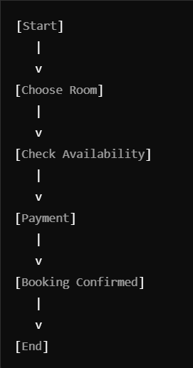

Guests Table:

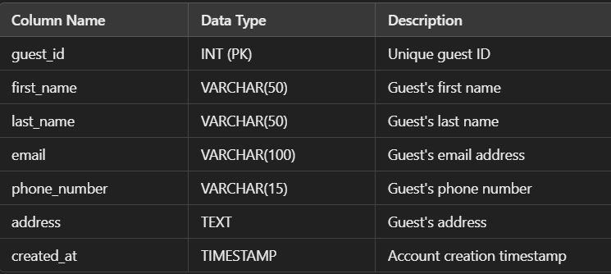

Rooms Table:

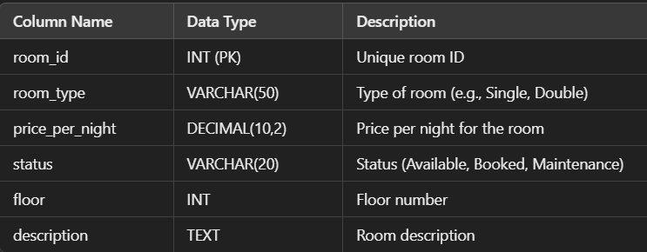

BOOKING TABLE:

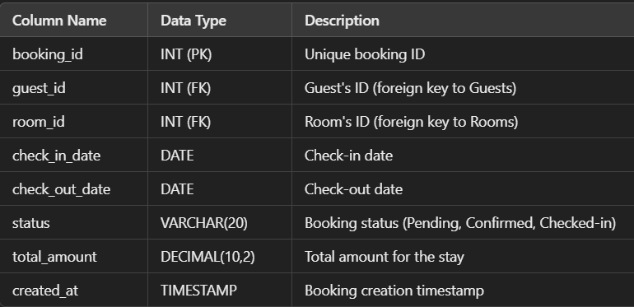

Billing Table:

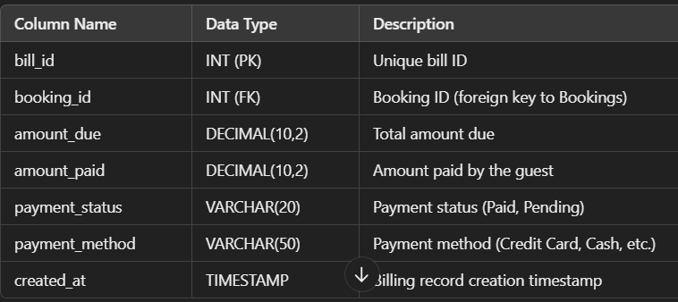

Amenities Table:

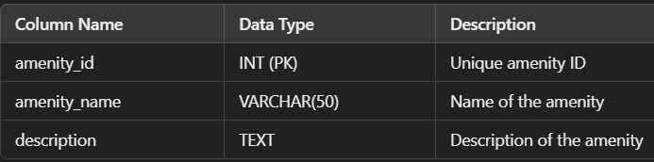

**Stored Procedures**

**Room Booking Procedure**

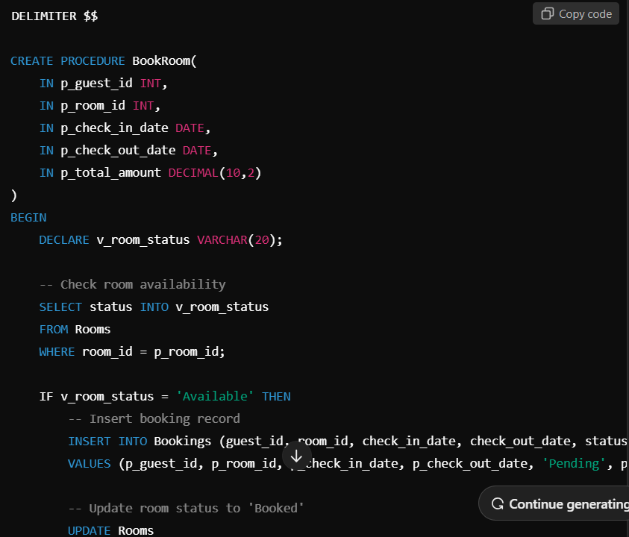

**Check-in Procedure**

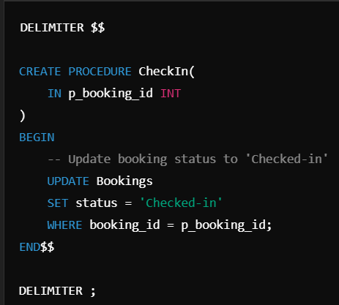

**SQL Queries for Reporting**

**Room Availability Report**

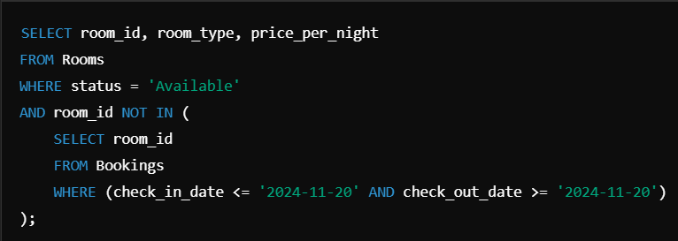

**Guest History Report**

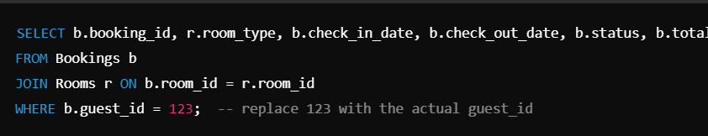

**Billing Summary:**

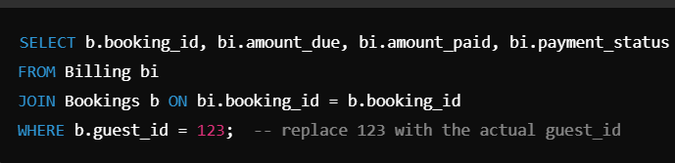

**Ensuring ACID Properties**

* **Atomicity: In stored procedures (e.g., BookRoom, CheckIn, CheckOut), the entire operation is treated as a single unit. If an error occurs (e.g., room not available), all changes are rolled back, ensuring atomicity.**
* **Consistency: Database constraints (e.g., foreign keys) ensure that the data remains consistent. For example, a booking can only be made if the room is available.**
* **Isolation: Transactions should be used to ensure that no two operations (e.g., booking) can interfere with each other. The SQL queries should be wrapped in transactions.**

